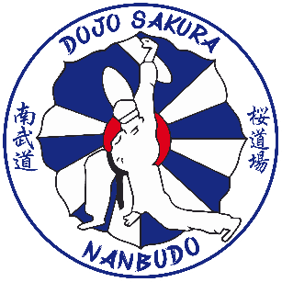

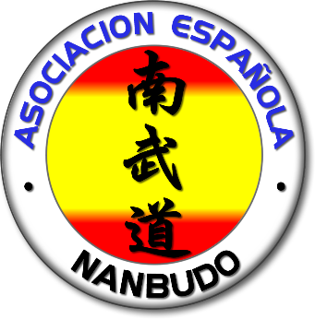

INTERNATIONAL STAGE HUESCA 2026
20 – 21 – 22 MARCH 2026

MARCH 20
FROM 7:00 PM TO 9:00 PM INTERNATIONAL STAGE
PLANNED PROGRAM KI NANBU TAISO
RANDORI + NININGAKE
BASIC KATA + BUNKAI (Details and doubts)
KEIRAKU TAISO

MARCH 21
FROM 10:00 AM TO 12:00 PM INTERNATIONAL STAGE
PLANNED PROGRAM KI NANBU TAISO
RANDORI + SUWARI ADVANCED RANDORI
SUPERIOR KATA + BUNKAI (Details and doubts)
KEIRAKU TAISO

FROM 4:00 PM TO 5:30 PM INTERNATIONAL STAGE
PLANNED PROGRAM TENCHI UNDO
SOTAI BASIC + SUPERIOR
BASIC + SUPERIOR KATA

FROM 7:00 p.m. to 8:30 p.m. Theoretical class “KEIRAKU-HEALTH AND NANBUDO THEME” BLUE ROOM CASINO OF HUESCA

9:30 PM INTERNATIONAL STAGE DINNER
MARCH 22
FROM 10:00 A.M. TO 11:30 A.M. INTERNATIONAL STAGE
PLANNED PROGRAM KI DO HO
BASIC + SUPERIOR KATA
SUWARI RANDORI + KANTSETSU RANDORI
FROM 11:30 AM TO 12:30 PM SPECIAL INTERNATIONAL STAGE FOR CHILDREN
P.S. During the Stage sessions, there will be joint work and work in which the Nanbudokas will be divided into 2 Tatamis, depending on their program and level, to make the most of the time and experience of the Dai Shihan, creating a dynamic environment.
STAGE PLACE; CENTER POLIDEPORTIVO DEL PARQUE Avenida Juan XXIII HUESCA
STAGE 50 EUROS
CHILDREN'S STAGE 10 EUROS (Sunday class only)
STAGE SATURDAY DINNER 25 EUROS

REGISTRATIONS (deadline march 14)
MARIANO CARRASCO + 34 636 95 15 51
marianocarrasco1@gmail.com
ALMA LARA + 34 630 60 36 24
almalara79@gmail.com

Zaragoza Airport (Saragossa) (we will pick you up and take you)
Barcelona Airport (train and bus to Huesca or Zaragoza)
Pau Airport -France- (car rental to Huesca)

POSSIBLE ACCOMMODATIONS (there are many more, all within these prices, look at booking.com)

RUGACA HOSTEL
5 MINUTES WALKING TO THE SPORTS CENTER.
CITY CENTER
www.booking.com HOSTAL RUGACA HUESCA

HOSTAL EL CENTRO HUESCA
7 MINUTES WALKING TO THE SPORTS CENTER.
CITY CENTER
http://www.hostalelcentrohuesca.es/
www.booking.com HOSTAL EL CENTRO HUESCA

SANCHO ABARCA HOTEL ****
2 MINUTES WALKING TO THE SPORTS CENTER.
www.booking.com HOTEL SANCHO ABARCA
https://www.hotelsanchoabarca.com/

HOTEL PEDRO I ARAGON ****HIGHER
1 MINUTE WALK TO THE SPORTS CENTER.
www.booking.com HOTEL PEDRO I HUESCA
https://www.hotelpedroidearagon.com/

