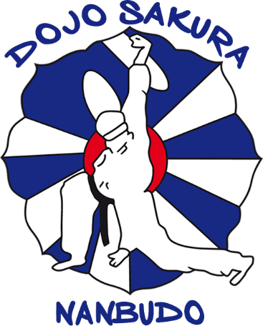

INTERNATIONAL NANBUDO STAGE IN HUESCA
APRIL 01, 02 AND 03, 2022

POLIDEPORTIVO DEL PARQUE
C/ San Jorge 22001 Huesca, España

Dear Nanbudokas, we send you the information of the International Nanbudo Stage that will take place in Huesca on April 1, 2 and 3. Likewise, we send you a list of possible accommodation in Huesca, all of which are a maximum 5-minute walk from the sports center. Regarding dinners and meals we are working to give you the best options and prices, we will send you this information as soon as possible.

Regarding the Covid measures in Spain, the mask is necessary to train, at the moment there are no other restrictions, if there were changes we would notify you. Trainings are carried out in a "normal" way, as always.

TRAINING SCHEDULES

APRIL 01 FRIDAY FROM 7:00 PM TO 9:00 PM

APRIL 02 SATURDAY FROM 10.00 TO 12.00 HOURS
FROM 17.00 TO 19.00 HOURS

APRIL 03 SUNDAY FROM 10.00 TO 13.00 HOURS

INTERNATIONAL STAGE PRICES

ADULTS 30 EUROS
CHILDREN 10 EUROS (only on Sunday from 11.00 to 12.00)

ACCOMMODATIONS

HOTEL PEDRO I DE ARAGÓN **** (+34 974 220 300)

www.hotelpedroidearagon.com

85-90 euros double room

HOTEL ABBA HUESCA **** (+34 974 292 900)

www.abbahoteles.com

80-85 euros double room

HOTEL SANCHO ABARCA **** (+34 974 220 650)

www.hotelsanchoabarca.com

80-85 euros double room

HOSTAL RUGACA (+34 974 226 449)

www.infohostal.com

45-50 euros double room

HOSTAL EL CENTRO (+34 974 226 823)

www.hostalelcentrodehuesca.es

45-50 euros double room

HOW TO GET FROM OUTSIDE SPAIN

The nearest airports are

Zaragoza (Saragossa)

Pau (Pau-Pyrénées – France)

Barcelona

**** When you confirm your flight, we will give you the best options to get to Huesca and back*****, if you arrive at Zaragoza airport we will pick you up and take you.

CONTACT AND REGISTRATION

MARIANO +34 636 951551

marianocarrasco1@gmail.com

ALMA +34 630603624

almalara79@gmail.com

