Sandefjord Training Seminar

With 9 Dan Stéphane Carel

May 31. – June 02. 2019

Sandefjord Nanbudo Club invites to a training seminar to be held by 9 Dan Stéphane Carel. The seminar will be held in our dojo in Sandefjord.

Address: Hystadveien21,Sandefjord Norway

The seminar will start on Friday 31 may at 18:00 and end Sunday 02 June at around 15:00. Daily schedule will be announced later
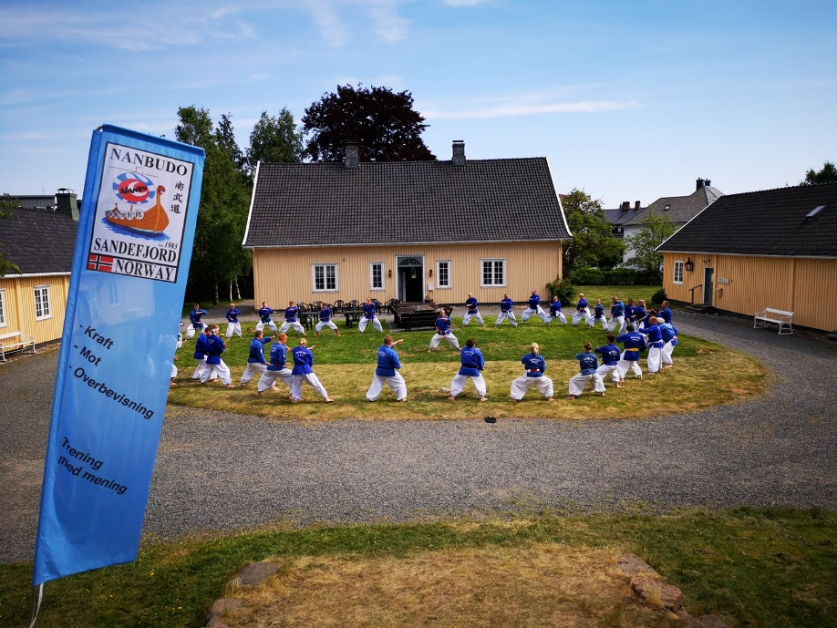

Fees:
Whole weekend: 500 NOK and include light lunch at the Dojo Area.
Single events:200 NOK

There will be a Seminar Dinner on Saturday. Time, place and price will be advised later.

Registration & Payment: In dojo from 30 minutes before training session

Travelling
From abroad you will reach Sandefjord either via our local airport -served by KLM from Amsterdam and SAS from Copenhagen – or via Oslo Airport Gardermoen and direct train to Sandefjord.

Accommodation:
You will find links to various accommodation at: https://www.visitvestfold.com/en/sandefjord/
We do not have any contract or cooperation with any hotels. We can however assist if you need info.

If private accommodation is preferred will try to arrange as far as possible.

Let us know when you arrive and where you will stay, and we will transport you to and from the dojo during the seminar.

For our further planning, we will need response if you will attend, or plan to attend this seminar.
Kindly send email to: cl-micsw@online.no

Remember to bring your Nanbudo passport.

For further information, please contact:
Name | E-mail | Mobile phone
Michael Swerin | cl-micsw@online.no | +47 992 39 533
Roy Kristoffersen | Roy.Kristoffersen@dnvgl.com | +47 907 66 463

Seminar schedule

Friday
Activity | From | To
Adults | 18.00 | 19:30
Social Event | 20:30 | 23:30

Saturday
Activity | From | To
Adults | 10:00 | 11:30
Lunch | 11:30 | 12:30
Children | 13:30 | 14:30
Adults | 14:30 | 16:00
Dinner | 19:00 | ?

Sunday
Activity | From | To
Adults | 11:00 | 13:00
Graduation, Children | 13:30 | 14:00
Closing | 14:00 | 14:30

