17thINTERNATIONALMEMORIAL TOURNAMENT
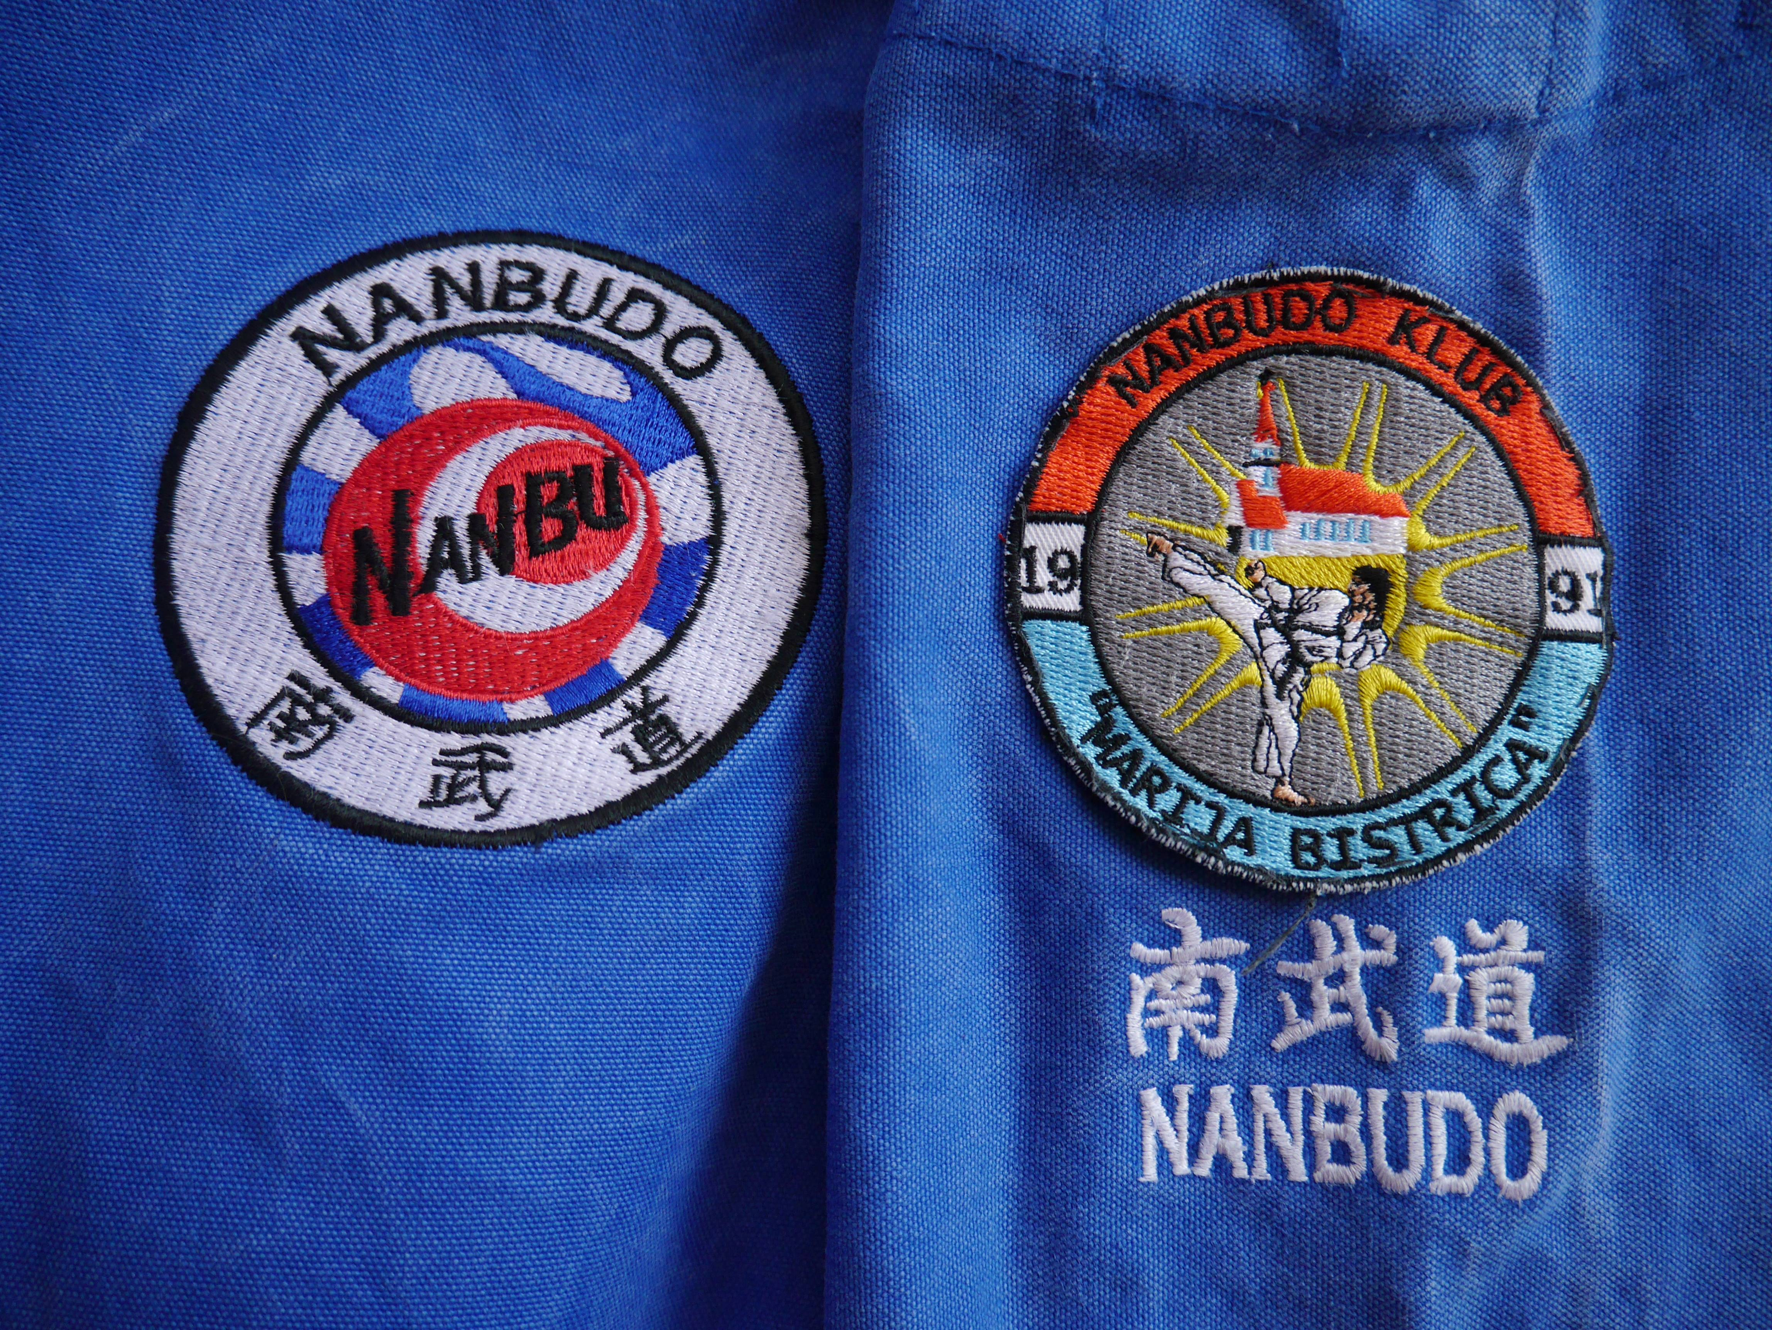
Zdravko Mikuš 2019. / 24.-26.MAY 2019.
I N F O
Nanbudo club Marija Bistrica invites you to the 17thZdravko Mikuš Memorial Tournament.
Traditionallythe tournament will be held in the dojo of Nanbudo club Marija Bistrica (the gym of Marija Bistrica primary school).
All information regarding tournament organization and accommodation can be obtained by e-mail:
babic.ivancica@gmail.com
marko-lezo@hotmail.com
edija.redzic@gmail.com

A P P L I C A T I O N
The official organizer of the competition, in charge of the competition program and competition regulations is Nanbudo club Marija Bistrica.
The competition will be conducted by a judge-competitive rules of WNF. CINDA representative in charge of the competition will be Robert Sikora robi.sikora@gmail.com/B. Užarevićbranko.sunce@gmail.com /Fabienne Jacquesjfabienne@hotmail.com/ Tibor Suveg suvegtibor@gmail.com
Registrations will be accepted only on the approved registration forms.Team coaches are obliged to register their competitors byMay 1th 2019.at the following e-mail addresses: / branko.sunce@gmail.com

Accommodation
Private apartments or hotel www.hotelkaj.hr
The apartments are located next to the sports hall where the competition takes place. Price is 10 €/night, please make your reservations directly with the organizers at:
edija.redzic@gmail.com
marko-lezo@hotmail.com
babic.ivancica@gmail.com
Reservation deadline is May 1th 2019.
COMPETITION INFO
Location: Marija Bistrica Primary School
Competition requirements:
75 KN / 10 EUR competition fee - individual
150 KN / 20 EUR competition fee - team
nanbudo passport with the license for 2019.,
medical certificate
Friday, May 24th 2019
REFEREES SEMINAR & DRAW
Saturday, May 25th 2019
CATEGORIES UP TO 16 YEARS
Sunday, May 26th 2019
CATEGORIES JUNIORS / SENIORS

S C H E D U L E
Friday, May 24th 2019
19:00-20:00 – referees seminar
21:15 – competition's draw
/according to the received registrations/
Saturday, May 25th 2019
CATEGORIES UP TO 16 YEARS
07:30h – Official registration of the competitors
08:00 – 10:00h – Opening Ceremony
10:00 – KATA COMPETITION
Individual KATA categories (M/F)
- up to 10 years of age (shihotai kata)
- between 10 and 12 years of age
- between 12 and 14 years of age
- between 14 and 16 years of age
Team KATA categories (M/F)
- between 14 and 16 years of age
(younger competitor can also participate as a member of a kata team)
13:00 – 14:30 – Lunch break
14:45 – JU RANDORI COMPETITION
Individual JU RANDORI categories (M/F)
- up to 10 years of age (randori ichi no kata / gyaku)
- between 10 and 12 years of age
- between 12 and 14 years of age
- between 14 and 16 years of age
(weight categories will be introduced according to the pre-registration data)
Team JU RANDORI categories (M/F)
- between 14 and 16 years of age
(younger competitor can also participate as a member of a team in the responsibility of coaches)
17:30 – Medals Ceremony
20:30h - Diner

Sunday, May 26th 2019
CATEGORIES JUNIORS / SENIORS
07:30 – Official registration of the competitors
08:15 – KATA COMPETITION
Individual KATA categories (M/F)
- juniors
- seniors
HEAVY and LIGHT ( only for senior M )
(weight categories will be introduced according to the pre-registration data)
Team KATA categories (M/F)
- seniors
12:30 – 13:30 – Lunch break
13:45 – JU RANDORI COMPETITION
Individual JU RANDORI categories(M/F)
- juniors
- seniors
(weight categories will be introduced according to the pre-registration data)
Team JU RANDORI categories (M/F)
- seniors
17:00 – Medals Ceremony
18:00 – Closing Ceremony

20:30h Diner

If ther will be a time on Saturday, we will do maybe some categories from Sunday — junior KATA or JR.

The organizer reserves the right to change schedule!

