16th INTERNATIONAL MEMORIAL TOURNAMENT
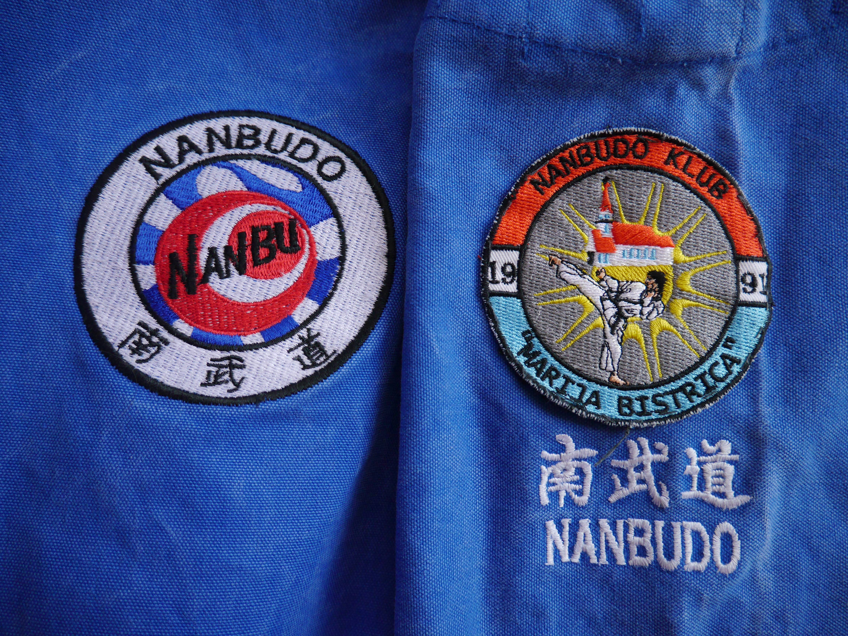
Zdravko Mikuš 2018. / 11.-14.OCTOBER 2018.
I N F O
Nanbudo club Marija Bistrica invites you to the 16th Zdravko Mikuš Memorial Tournament.
Traditionally the tournament will be held in the dojo of Nanbudo club Marija Bistrica (the gym of Marija Bistrica primary school).
All information regarding tournament organization and accommodation can be obtained by e-mail:
babic.ivancica@gmail.com
marko-lezo@hotmail.com
edija.redzic@gmail.com

A P P L I C A T I O N
The official organizer of the competition, in charge of the competition program and competition regulations is Nanbudo club Marija Bistrica.
The competition will be conducted by a judge-competitive rules of WNF. CINDA representative in charge of the competition will be Robert Sikora robi.sikora@gmail.com / B. Užarević branko.sunce@gmail.com / Fabienne Jacques jfabienne@hotmail.com / Tibor Suveg suvegtibor@gmail.com
Registrations will be accepted only on the approved registration forms. Team coaches are obliged to register their competitors by September 28th 2018. at the following e-mail addresses: / branko.sunce@gmail.com

Accommodation
Private apartments or hotel www.hotelkaj.hr
The apartments are located next to the sports hall where the competition takes place. Price is 10-15 €/night, please make your reservations directly with the organizers at: / edija.redzic@gmail.com/
marko-lezo@hotmail.com /babic.ivancica@gmail.com

Reservation deadline is October 1th 2018.

Transportation
Transport from Zagreb (airport) to Marija Bistrica will be provided by the organizer.

C O M P E T I T I O N I N F O

Location: Marija Bistrica Primary School

Competition requirements:
- 75 KN / 10 EUR competition fee - individual
- 150 KN / 20 EUR competition fee - team
- nanbudo passport with the license for 2018.,
- medical certificate

Friday, October 12th 2018 - REFEREES SEMINAR & DRAW

Saturday, October 13th 2018 - CATEGORIES UP TO 16 YEARS

Sunday, October 14th 2018 - CATEGORIES JUNIORS / SENIORS

S C H E D U L E
Thurseday October 11 th 2018
-more details about seminar we will anounce soon
19:00-21:00 seminar by Sergio Medina CHICHO - FREE FOR EVERYONE
Friday, October 12th 2018
Morning time:seminar by SergioMedina CHICHO
- FREE FOR EVERYONE
19:00-20:00 — referees seminar
20:00 seminar by Sergio Medina CHICHO
- FREE FOR EVERYONE
21:15 — competition's draw
/according to the received registrations/

Saturday, October 13th 2018
CATEGORIES UP TO 16 YEARS

07:30h — Official registration of the competitors

08:00 — 10:00h — Opening Ceremony

10:00 — KATA COMPETITION
Individual KATA categories (M/F)
- up to 10 years of age (shihotai kata)
- between 10 and 12 years of age
- between 12 and 14 years of age
- between 14 and 16 years of age

Team KATA categories (M/F)
- between 14 and 16 years of age
(younger competitor can also participate as a member of a kata team)

13:00 — 14:30 — Lunch break

14:45 — JU RANDORI COMPETITION
Individual JU RANDORI categories (M/F)
- up to 10 years of age (randori ichi no kata / gyaku)
- between 10 and 12 years of age
- between 12 and 14 years of age
- between 14 and 16 years of age
(weight categories will be introduced according to the pre-registration data)

Team JU RANDORI categories (M/F)
- between 14 and 16 years of age
(younger competitor can also participate as a member of a team in the responsibility of coaches)

17:30 — Medals Ceremony

20:30h Diner

Sunday, October 14th 2018
CATEGORIES JUNIORS / SENIORS

07:30 — Official registration of the competitors

08:15 — KATA COMPETITION
Individual KATA categories (M/F)
- juniors
- seniors
Like last year (only for senior M)
HEAVY and LIGHT
(weight categories will be introduced according to the pre-registration data)

Team KATA categories (M/F)
- seniors

12:30 — 13:30 — Lunch break

13:45 — JU RANDORI COMPETITION
Individual JU RANDORI categories (M/F)
- juniors
- seniors
(weight categories will be introduced according to the pre-registration data)

Team JU RANDORI categories (M/F)
- seniors

17:00 — Medals Ceremony

18:00 — Closyng Ceremony

If ther will be a time on Saturday, we will do maybe some categories from Sunday — junior KATA or JR.

The organizer reserves the right to change schedule!

